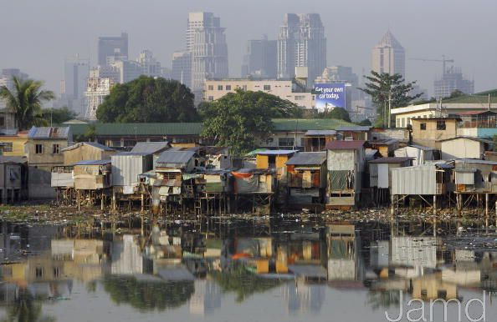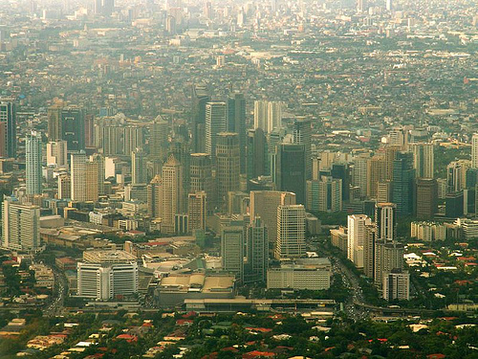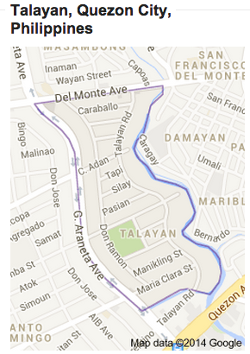

Poverty is extremely prevalent in the Metro Manila region of the Philippines and it seems as if an urban poor community is around every corner. The country’s poverty rates are high as about a quarter of the country lives below the poverty line (18,000 pesos (400USD)/year). 1 Each household’s standard of living greatly varies from community to community and from home to home, but how do we assess poverty in order to know where the greatest need is? Do we measure poverty by the household income? Material belongings? The building materials of the home? Poverty has different faces based on the cultural and geographical context.

For this project, I will be applying CASHPOR’s Progress out of Poverty Index (PPI) to the context of a community in the Philippines and will use their criteria to assess the level of poverty. In this project, the surveyed homes are in the Talayan community in the Santo Domingo area of Quezon City in Metro Manila. This poverty assessment that is designed for the Indian context utilizes a combination of criteria such as building materials of the home, household income, and household possessions in order to calculate a numerical score and assess how below or above the household is from the poverty line.

Of the households surveyed, all of the members of the home seemed to be joyful and were not despondent about their current living conditions. I have noticed that the Filipino people are very positive and resilient in all circumstances, and it has caused me to look differently at poverty, which is why I chose to title this project as a measuring of *wealth* and not *poverty*. Filipinos focus on what they have and not what they lack.

# **Introduction**

Measuring Wealth

Using CASHPOR’s PPI to Assess the Poverty of an Urban Poor Community in Metro Manila

**Amanda Tam**

**TUL560: Theology of Community Economics**

**Dr. Viv Grigg**

**Summer 2014**

**TUL560 Poverty Assessment A. Tam 2**

Below are the criteria that the CASHPOR Progress Out of Poverty Index uses in order to calculate a numerical score to assess the level of poverty of a community. There are ten main indicators and corresponding values based on the answers to these indicator questions that determine the score. These criteria and their associated values are are as follows:

All of the above information regarding CASHPOR’S PPI can be found on the CASHPOR Micro Credit website: <http://www.cashpor.in/ppi.html> 2

**INDICATOR VALUE POINTS**

|  |  |  |  |
| --- | --- | --- | --- |
| **1** | **How many people aged 0 to 17 are in the household.** | 1. **Five or more** 2. **Four** 3. **Three** 4. **Two** 5. **One** 6. **None** | **0 4 8 13 20 27** |
| **2** | **What is the household’s principal occupation?** | 1. **Laborers** 2. **Others** 3. **Professionals** | **0**  **8**  **14** |
| **3** | **Is the residence all pucca?** | 1. **No** 2. **Yes** | **0 4** |
| **4** | **What is the household’s primary source of energy for cooking?** | 1. **Firewood and chips, charcoal, or none.** 2. **Others** 3. **LPG** | **0**  **5 17** |
| **5** | **Does the household own a television?** | 1. **No** 2. **Yes** | **0 6** |
| **6** | **Does the household own a bicycle, scooter, or motorcycle?** | 1. **No** 2. **Yes** | **0 5** |
| **7** | **Does the household own an almirah/dressing table?** | 1. **No** 2. **Yes** | **0 3** |
| **8** | **Does the household own a sewing machine?** | 1. **No** 2. **Yes** | **0 6** |
| **9** | **How many pressure cooker or pressure pans does the household own?** | 1. **None** 2. **One** 3. **Two or more** | **0 6 9** |
| **10** | **How many electric fans does the household own?** | 1. **None** 2. **One** 3. **Two or more** | **0 5 9** |

*Note: The greater the total score (in the bottom row), the household is more likely to be above the country’s poverty line.

**TUL560 Poverty Assessment A. Tam 3**

## **Collected Data from the Talayan Community**

|  |  |  |  |  |
| --- | --- | --- | --- | --- |
| **Indicator** | 1 | 2 | 3 | 4 |
| # of children in home | 2 | 3 | 0 | 3 |
| Main source of income | Works at a printing press | Fixes up homes to be resold | Laborer | Shopkeeper |
| Home | Cement w/ tin roof | Cement w/ tin roof | Cement w/ tin roof | Cement w/ tin roof |
| Energy for cooking | Gas | Gas | Gas | Gas |
| Television | Yes | No | No | Yes |
| Bike, scooter, or motorcycle | No | No | No | No |
| Dressing table | Plastic container | Plastic container | Plastic container | Plastic container |
| Sewing machine | No | No | No | No |
| Pressure Cooker/Pan | Yes (1) | Yes (1) | Yes (1) | Yes (1) |
| Electric fans | Yes (4) | Yes (1) | Yes (1) | Yes (1) |
| **Total Score** | 58 | 48 | 51 | 54 |

Using CASHPOR’S PPI in Metro Manila

Although I think that CASHPOR’s Progress Out of Poverty Index assessment method can be quite effective due to the criteria by which it measures poverty, the indicators must be adjusted based on the cultural and geographical context that it is used in due to the fact that the PPI was designed for use in India. Several of the criteria are irrelevant to the Filipino context, such as indicator #8 which asks about the presence of a sewing machine (something I have yet to see in a Filipino home; they are only found at tailoring shops), but these criteria can be easily substituted for more applicable criteria.

For indicator #9, I replaced the “pressure cooker” with “rice cooker”, since it is a pretty common kitchen appliance found in many Filipino homes. In addition, indicator #10 which asks “How many electric fans does the household own?” may be quite different in the context of the Philippines than in the Indian context. In the urban poor communities in Metro Manila, I have yet to come across a family’s home that did not own an electric fan of some sort (even if the fan frightened me because it did not have a grill covering the spinning blade). Due to the extreme humidity and heat in Metro Manila, it is expected that every home will have at least one electric fan, whether or not it is of good quality or very effective at producing cool air, but perhaps I have not been to a community that does not have access to electricity yet.

In terms of using the quality of the home as an indicator for assessing poverty, I think that in addition to using the building materials as a level of wealth, size should be accounted for. Although all the homes I surveyed were made of cement with tin roofs, some are extremely small (the size of a bedroom in other homes). The size of the home is something that should be accounted for, especially in relation to the number of people that are living in the household. I have seen some homes whose walls are supported by plywood boards, so in addition to size, building materials are an accurate indicator.

**TUL560 Poverty Assessment A. Tam 4**

Cont.

While researching for other poverty measurement surveys in the PI, I came across a poverty assessment tool for the Philippines’ context that was produced by USAID in 2010. It was surprisingly similar to the CASHPOR PPI, but had additional questions that went beyond the household. USAID states that their Poverty Assessment Tools (PAT) typically uses the household as the unit of measurement of poverty, but in measuring poverty in the Philippines, the family is actually the unit of measurement used. Due to the highly relational culture, I am not surprised that the family plays a unique role in some poverty assessments in the PI. This survey is based on a Annual Poverty Indicators survey produced by the Government of the Philippines and has several different criteria such as the type of toilet, if all children were going to school, and the presence of a sala set.3. I would be curious as to how homes in India would score using this particular survey.

**Conclusion** Using the CASHPOR PPI to assess the wealth of a household in the context of the Philippines appears to be moderately accurate, but some of the indicator values and their corresponding points need to be adjusted to be more culturally applicable. According to the CASHPOR PPI, the four households that were surveyed using the PPI were relatively well off; I would mostly agree with this fact due to the fact that Talayan is an older community and is rather developed. The newer communities of Metro Manila are much poorer and lack many basic resources and facilities, and these communities are typically situated towards the edges of the Metro Manila region as these communities are being pushed to the outskirts (Talayan is in a pretty central location in Quezon City). In my opinion, two of the four scores (Homes #2 and #3) did not seem to accurately reflect the circumstances of the households as there are other extraneous factors that I felt needed to be accounted for in the context of an urban poor community in the Philippines. It is difficult to assess poverty using 10 objective questions, but I recognize the purpose of keeping the survey brief in order to survey more homes in a shorter amount of time. Poverty is complex and it is difficult to encapsulate its many dimensions in a brief survey.

**References**

**1. “Fishermen, Farmers, and Children remain the poorest basic sectors.” Philippines Statistics Authority. July 2014. http://www.nscb.gov.ph/poverty/default.asp**

**2. “Progress Out of Poverty Index for India.” Cashpor Micro Credit. 2010. http://www.cashpor.in/ppi.html**

**3. “User Guide: USAID Poverty Assessment Tool for Philippines.” USAID. August 2010. Pp. 1-7. http://pdf.usaid.gov/pdf_docs/Pnadt227.pdf**

**TUL560 Poverty Assessment A. Tam 5**